Twin Oaks Art Docent ProgramTM Frequently Asked Questions
What is an Art Docent Lesson?
Each lesson will include a gallery presentation and discussion of approximately 4-6 images, followed by a hands-on art lesson. You can use the computer in the classroom to access the art docent website and project the images onto a screen in the classroom.
There are 8 lessons per grade level. Discuss the schedule with the teacher and, if applicable, other classroom docents. A mutually beneficial time should be determined for everyone.
How Do I find the Lesson Plans?
All lesson plans, gallery images and hands-on art lessons are available at: http://www.artdocentprogram.com.
Persons volunteering to be a Docent in the Art Docent ProgramTM will be given a user name and password to access the site.
What do the students do with the artwork they complete?
Docents provide each student with a paper bag portfolio. Often you can find a volunteer willing to make the bags. Some grocery stores will give you a stack of bags if you tell them it is for a school program. Bags should be labeled with each student’s name on the handle. The bags are generally kept in the classroom. Occasionally, Docents will keep the bags at their home. The bags are taken home by the students at the end of the year after the Art Show at Open House.

How do I make a paper bag portfolio?
- Use a brown paper bag with a handle.
- Take scissors and cut down the middle of one side of the bag.
- Cut the bottom of the bag off completely.
- Straighten out the whole bag and turn it inside out to hide the company’s printed information.
- Fold the bag back in half so the handles match up and the bag lies flat.
- Staple or tape the side and bottom of the bag where the bag has been cut.
- Add the students name to handle of the bag.
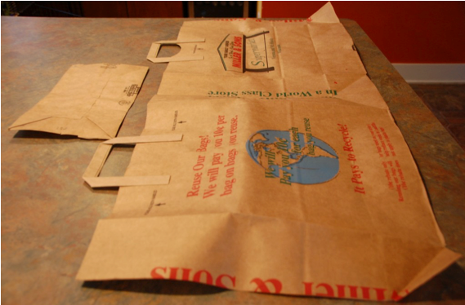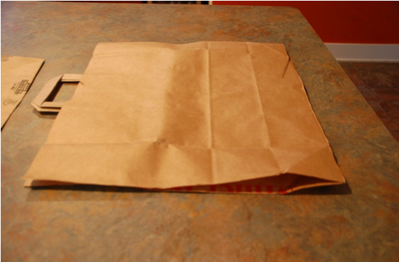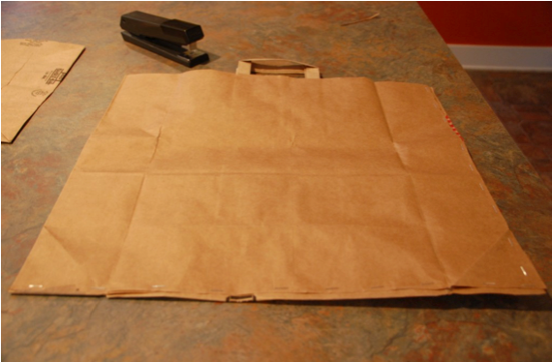
Where do I get the art supplies?

The Art Docent supply cabinets are located in the copy room in the office behind Catherine Van Bieber. All cabinets are labeled with the supplies found within. If you need a specific material and can’t find it, please contact Amy Welch at (916) 521-7093.

How is the Art Docent ProgramTM funded at Twin Oaks?

At open house in May, the Art Docent ProgramTM holds at Art Show, where each student has a piece of art displayed. Parents can “purchase” the student’s artwork for a tax-deductible donation. The donations from the Art Show are the only source of funding to purchase supplies for the program.

